Experiment 3
Survey Report on Emerging Trends in Low-Code Application Development
Name: Rithika L
Roll No: 240701430
Application: Vehicle Service & Repair Request Management (Zoho Creator)
1. AIM
To study the emerging trends in low-code application development and understand how the Vehicle Service & Repair Request Management application can be developed efficiently using Zoho Creator. The experiment also compares traditional application development with low-code platforms and identifies their benefits and challenges.
2. Traditional Application Development vs Emerging Trends in Low-Code Application Development
Traditional application development requires developers to write code manually for the user interface, backend, database, validation, testing, and deployment. It requires programming knowledge and usually takes more time to complete.
Low-code application development uses visual tools such as drag-and-drop components, built-in forms, workflows, and automatic validations. It reduces development time and allows applications to be created with minimal coding.
Comparison Table
Feature | Traditional Development | Low-Code Development
Development Method | Manual coding | Drag-and-drop development
Development Speed | Slow | Fast
Coding Requirement | High | Low
User Interface | Built manually | Pre-built components
Database Integration | Manual | Built-in
Validation | Manual coding | Automatic validation
Deployment | Complex | Simple
The Vehicle Service Request application uses Zoho Creator's built-in form fields to collect customer details, vehicle details, service information, and scheduling details, making the development process much faster.
LC-10-Vehicle Service-Basic Fields (1).pdf
3. Benefits and Challenges of Low-Code Development
Benefits
- Faster application development.
- Easy drag-and-drop interface.
- Built-in validation for Email, Phone, Date, and Number fields.
- Automatic report generation.
- Workflow automation such as acknowledgement emails.
- Reduced development cost.
- Easy maintenance.
Challenges
- Limited customization for complex applications.
- Dependence on a specific platform.
- Advanced features may require scripting.
- Premium features require paid plans.
- Difficult migration to another platform.
4. Comparison of Existing Low-Code Platforms
Platform | Developer | Main Features | Best Use Case
Zoho Creator | Zoho | Forms, Reports, Workflows | Business Applications
Microsoft Power Apps | Microsoft | Office Integration | Enterprise Applications
OutSystems | OutSystems | Full-stack Development | Large Organizations
Mendix | Siemens | Visual Modeling | Enterprise Solutions
Google AppSheet | Google | Spreadsheet-based Apps | Mobile Business Apps
Among these platforms, Zoho Creator is suitable for this application because it provides built-in form fields, validation rules, report generation, and workflow automation without requiring extensive programming.
LC-10-Vehicle Service-Basic Fields (1).pdf
5. Vehicle Service & Repair Request Management Application
The Vehicle Service & Repair Request Management application is designed for automobile service centers to manage customer service requests efficiently. Instead of booking through phone calls, customers can submit their vehicle details through an online form.
The application collects the owner's name, contact details, vehicle information, service type, issue description, preferred service date, and authorization using Zoho Creator's basic form fields. After submission, the details are stored in the Service_Request_Report, allowing the service center to schedule vehicles and assign technicians easily.
Screenshots
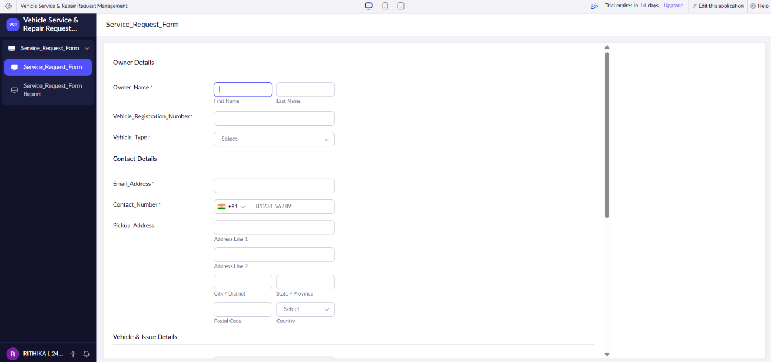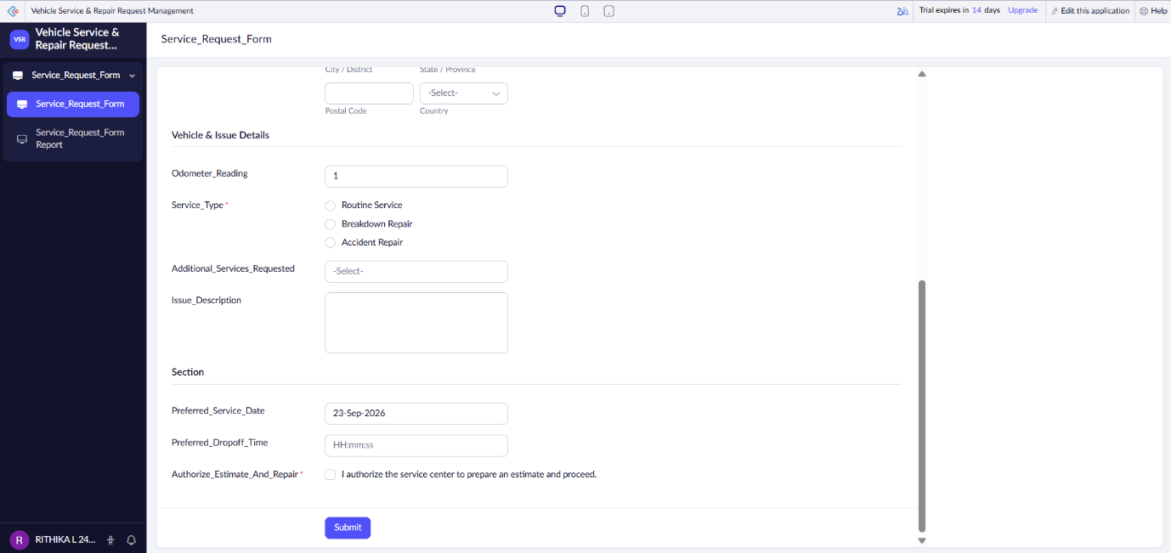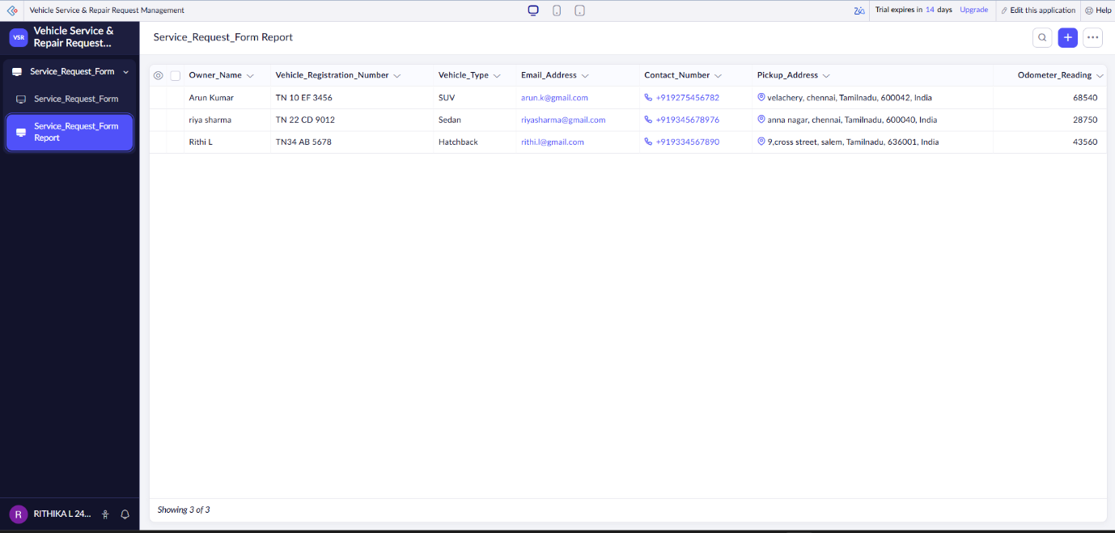

RESULT
The Vehicle Service & Repair Request Management application was successfully developed using Zoho Creator. The experiment showed that low-code platforms reduce development time through visual design, built-in validations, automated workflows, and report generation, making them an effective solution for rapid business application development.

